Ocean Adventure Field
MPA Watch

Time: 12 minutes
Group Size: 10-15 students
Grade Levels- 3rd – 8th grade
Location: MPA Entrance

OVERVIEW OF ACTIVITY

Students will engage in discussions about Marine Protected Areas in order to understand what they are, why they were created, how they are used, and how citizen scientists can help monitor human uses of MPAs. Students will collect meta data about the collection site and will participate in the collection of MPA Watch data according to the MPA watch protocol.

PERFORMANCE OBJECTIVES

Students will be able to:
- Identify consumptive and non-consumptive activities of humans in the MPA.
- Follow a standardized protocol for the collection of MPA Watch data.

ACTIVITY INTRO

Take students to the MPA sign and explain that Marine Protected Areas are designated protection areas with restricted types of usage. With very few exceptions, our State Marine Conservation Area does not allow removal of any organism or part of its habitat. Ask them to spend 60 seconds looking at the site. Then ask them to discuss any human activities they notice at the MPA. Encourage discussion. Explain that the MPA Watch program helps researchers identify how MPAs are used so they can better understand and determine how effective an MPA is at protecting and improving marine ecosystems.

CHALLENGE

Complete an MPA Watch Core Tally Sheet according to MPA Watch protocol.

MATERIALS

Materials per group:
- One bucket
- MPA Watch Surveys on clipboards (at least five)
- Vis-à-vis markers (at least five)
- Wet cloth
- Tide photo
- Laminated MPA map
- GPS /Compass (students can use iPhones)

ADVANCE PREPARATION

- Place bucket with all of the above materials in it out underneath the MPA sign before the program begins.
- Make sure you wet a rag/cloth and place in the bucket so the students can erase their data before the next group arrives.

TEACHING TIPS
- Break students into five groups. Encourage them to split activities within their groups so that students take turns viewing the MPA and recording data.

PROCEDURE

Engage: (5 minutes)
- Bring students near the top of the stairs and MPA sign. What human activities do you observe in the water or near the shore? (Answers will vary, but could include activities such as tide pooling, wildlife watching, kayaking, boating, etc.) Try to get all students to offer an observation.
- Show students the MPA sign and ask them what they know about Marine Protected Areas. Explain the role of MPAs.
- Cultivate personal stewardship in people who use coastal areas for recreation
- Increase biodiversity of coastal organisms by protecting a small piece of their ecosystem
- Educate others about ocean ecosystems
- Present the laminated MPA map for students to see the boundaries of the Dana Point MPA. Discuss the differences in acceptable activities in different areas.
Explore: (25 minutes)

- Present students with laminated MPA Watch Data Sheet (or have them use the MPA Watch Data Sheet in their CCSI Student Handbook.) Clarify the types of data that need to be collected and explain the on-shore and off-shore activities as necessary for accurate data collection.
- Students are to collect data according to the following protocol:
- Fill out the top portion of the data sheet, writing in your name, date, and transect ID.
- Walk to the designated start point and write in the metadata (Start Time, Weather, Tide, etc.)
- Now you can begin your survey. On your data sheet, include all activities inside the borders of the survey segment.
- If possible, walk along the mean high tide line to the stop point tallying people doing activities on the beach or in the water, as you steadily walk along the transect at a relatively even speed. Do not count people on bluffs, trails, roads, or parking lots.
- As you walk, record any activity in the appropriate categories when you pass the people doing that activity. MPA Watch volunteers count every single person they see except in the case of boats. (A boat gets one tally regardless of the number of people aboard). Each person or boat counted gets a tally in only one category.
- Do not count any activity that is happening behind you. Only count activity that is happening between you and the stop point as you pass them. Try not to double-count people if their activity changes.
- The only activities you can count if the person is not actively doing those activities in the water are surfing and SCUBA diving.
- Wildlife watching should only be counted if the activity is taking place on the beach or in the water- not on bluffs or trails. Wildlife watching is indicated by the use of binoculars or overt pointing and gesturing towards wildlife (such as whales, sea lions, etc.).
- Make sure to properly mark consumptive boating activities as: inactive or active in the appropriate section of the data sheet.
- When survey is complete, write the end time at the top of the data sheet.
- Total the tally marks in each individual box and circle the numbers when you finish your survey.
- You may survey the same area more than once a day, as long as it is on a new data sheet.

Other Tips:
- Do not compromise your safety to collect the data!
- Only mark the activity the person is actively engaging in and do not approach them
- Some surveys may have no activity – fill out data sheet and write “no activity”
- Fill out a separate data sheet for EACH survey
- Be aware of people approaching you - be friendly, provide them with a general overview of what you are doing and what an MPA is

Explain: (3 minutes)
- What types of activities did you observe?
- Of the activities you witnessed in the MPA, how do you think the activity could impact the coastal ecosystem?
- What types of observed activities could have the most impact on coastal ecosystems? The least impact on coastal ecosystem?
- How does the data collected by interested citizens benefit research institutions and make a positive change for the Marine Protected Areas in the long run? (If students have already been to the water quality station, ask students to consider how human usage might change if water quality is unacceptable.)

Extend: (3 minutes)
- As a citizen scientist, what kind of data would you collect at an MPA?
- How would you collect the data?
- What kind of tools would you need?
- Who would you involve in the collection of data? Why?
- How could you use your data?
- Who would you share it with?
- Would your analysis be locally focused or globally focused? Why?

Evaluate: (1 minutes)
- Is there an area near your home that you think should be protected? Why?
- What kinds of activities would you monitor?

BACKGROUND INFO

What are Marine Protected Areas or MPAs?

- MPAs protect ecosystems rather than individual organisms.
- Like parks protect wildlife and habitats on land, MPAs protect and restore wildlife and habitats in our ocean. The size and level of protection vary depending on the purpose of the MPA, some restrict fishing, while others allow compatible uses such as fishing and recreation to occur. By protecting entire ecosystems rather than focusing on a single species, MPAs are powerful tools for conserving and restoring ocean biodiversity, may provide benefits to cultural resources, and can help sustain local economies. In addition, MPAs contribute to healthier, more resilient ocean ecosystems that can better withstand a wide range of human impacts such as pollution and climate change. (California Marine Protected Areas, http://californiampas.org)

What Are the Different Kinds of MPAS?

- There are many different types of MPAs, ranging from highly restrictive to those that are designed as multiple-use, allowing fishing, recreation, extraction, and other human activities to occur within their boundaries. The most restrictive MPA are marine reserves, known as fully protected or no-take MPAs, which prohibit all fishing, mineral extraction, and other habitat-altering activities. Marine reserves allow fish, mammals, and other marine life to breed, feed, and thrive free of human interference.
- The National Marine Protected Areas Center has developed a Classification System that describes MPAs in functional terms using five characteristics common to most MPAs: 1) conservation focus; 2) level of protection; 3) permanence of protection; 4) constancy of protection; and 5) ecological scale of protection.
- A marine reserve or "no take" MPA is a highly protected type of MPA where removing or destroying natural or cultural resources is prohibited. Marine reserves are rare in the United States, with about 3 percent of U.S. waters in these no-take areas. Reserves protect whole ecosystems, allowing them to return toward a more natural and balanced state. Monitoring studies from marine reserves have shown that biomass, the size and density of organisms and the richness or diversity of species all increase within marine reserves. Reserves can be an effective way to preserve biodiversity by protecting communities and providing refuge for rare organisms
- In a state marine conservation area (SMCA), it is unlawful to injure, damage, take, or possess any living, geological, or cultural marine resource for commercial or recreational purposes, or a combination of commercial and recreational purposes that the designating entity or managing agency determines would compromise protection of the species of interest, natural community, habitat, or geological features. The designating entity or managing agency may permit research, education, and recreational activities, and certain commercial and recreational harvest of marine resources. (PRC Section 36710(c)) - https://www.wildlife.ca.gov/Conservation/Marine/MPAs/FAQs#27530610-what-are-marine-protected-areas-mpas-

(Marine Protected Areas NOAA, https://marineprotectedareas.noaa.gov)
Why were MPAs created?

- MPAs were created to protect and preserve coastal marine ecosystems while allowing for human uses of these areas of California’s coasts.

What is the Role of MPA Watch?

- MPA Watch is a citizen science monitoring program that trains volunteers to observe and collect data on human uses of coastal and marine resources both inside and outside of marine protected areas (MPAs). Volunteers use standardized protocols to collect relevant, scientifically rigorous, and broadly accessible data.
- Data are meant to inform the management, enforcement, and science of California's marine protected areas. Citizen scientists collect data about the ways humans engage in consumptive or non-consumptive behaviors as recreational or commercial participants. The information allows us to track how the public uses coastal areas
- By involving local communities in this MPA monitoring, MPA Watch programs inspire and empower stewardship, and educate the public about California’s ocean ecosystems.
- Not only do local volunteers learn about their coastal environment and become "citizen scientists" and stewards of the area, but they generate quantities of monitoring data that would not be possible under the current state budget.

South Coast MPA Region Facts:

- Dana Point Marine Life Refuge is located in the South Coast MPA Region and is designated as a State Marine Conservation Area (SMCA).
- Third of the statewide MPA regions to be implemented
- Ranges from Point Conception in the north to the U.S./Mexico border in the south
- Consists of 50 MPAs and 2 special closure areas
- Of the 50 MPAs, 37 are new and 13 were pre-existing MPAs of the northern Channel Islands
- Represent approximately 354 square miles or about 15% of state waters
- Of the 37 new MPAs established, 4.9% or 116 square miles are no-take
- Was adopted in December 2010 and went into effect in January 2012
- Includes:
  - 21 State Marine Conservation Areas (SMCA)
  - 10 no-take State Marine Conservation Areas (SMCA)
  - 19 State Marine Reserves (SMR)
  - 2 Special Closures (SC)
  - Leaves 85% of South Coast state waters open for fishing

Below is a map of South Coast Region MPA Map.

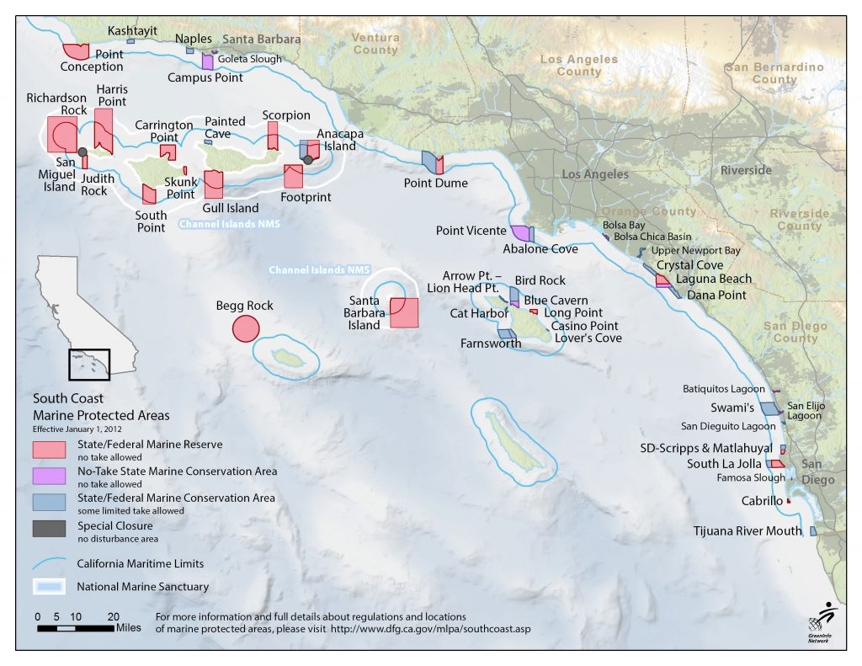
Link: http://californiampas.org/wpcontent/uploads/2016/08/SouthCoast_EducationalMap_StateFed_NoBold-1-1024x791.jpg

Additional Resources:
- More information about California MPAs and how to get involved:
http://www.californiampas.org/
- California Department of Fish and Wildlife-MPAs https://www.wildlife.ca.gov/Conservation/Marine/MPAs
- The California Ocean Protection Council (OPC):
- The OPC was created in 2004 to help protect, conserve, and maintain healthy coastal and ocean ecosystems and the economies they support. The OPC works with diverse interests and provides the leadership needed to meet the accelerating and complex challenges of our time as set forth in the California Ocean Protection Act
- Marine Protected Areas are scattered across the entire globe! For more information, visit the MPA Global website
http://www.mpaglobal.org/index.php?action=summary_by_country

ACTIVITY RESOURCES

The following materials will be utilized in the program or are resources that could be included in materials for program. 